防雨罩使用说明书
Waterproof Cover Manual
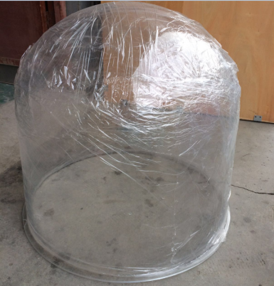
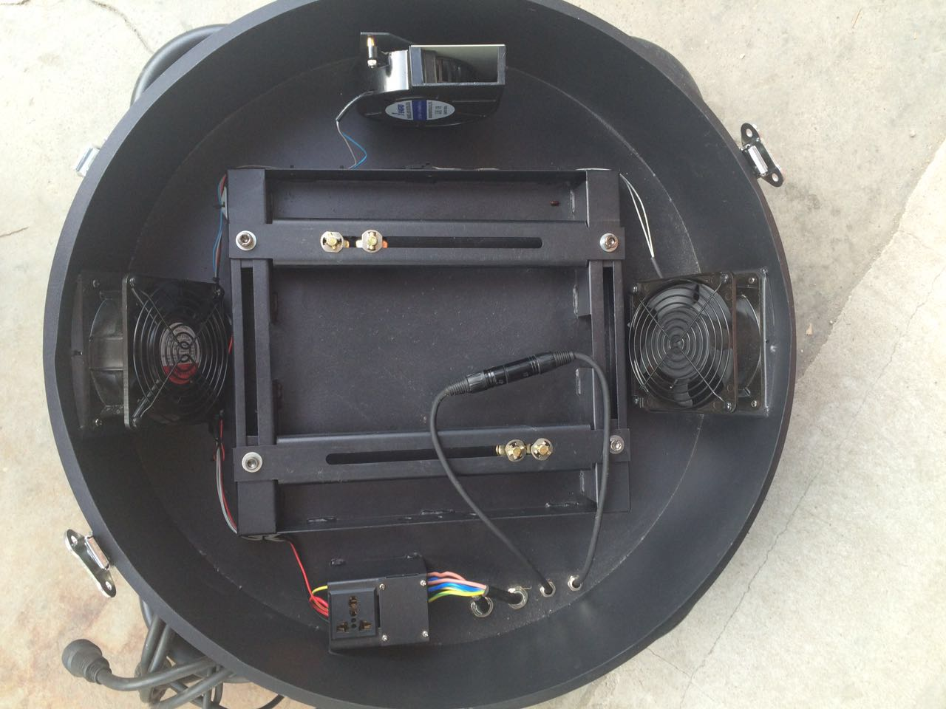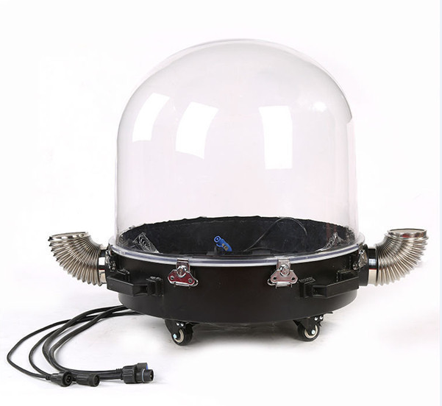

产品参数：
■电压范围：220V
■内部工作温度：0°- 36°
■工作环境温度(℃): -20°- 40°
■高: 720mm
■直径: 610mm
■净重: 19KG
■IP指数: IP54
■灯具控制: DMX512
■安装方式:可以平放、侧挂，吊挂进出风弯管可以旋转至任意角度
■功能: 防雨,户外使用
■材质: 透明罩是美国进口的工程塑料制造而成，具有高透光性、抗紫外线、
不发黄、不易破裂等特性。
■信号及电源连接：配有两条2*0.3m²防水信号线和两条3*2.5m²防水电源线，
最大功率2500W.
■使用范围: 200W,230W光束灯或者其他类似体积的灯具。
■保质期：1年

■ voltage range:220V
■Inside Working Temperature (℃): 0°- 36°
■Environment Working Temperature: -20°- 40°
■Height: 720mm
■Diameter:610mm
■N/W: 19KG
■Protection degree: IP54
■Control: DMX512
■Installation: Can be flat, side hanging, hanging, in and out of the wind pipe can
rotate to any angle.
■Function: Raining proof, for outdoor use
■Material: Transparent cover is made by the US imported engineering
plastics with high light penetration, anti-ultraviolet radiation, not
yellow, not easily broken.
■Signal And Power Connections: With two 2*0.3m²waterproof dmx cable and
two 3*2.5m² waterproof power line.,maximum power2500W.
■Suitable: 200W,230W beam lights and similar sized lights.
■Warranty: 1 year

安装方案：
Installation:

- 底座板Base
2.将配套胶圈与底座板连接 Fix the matched ring on the base.
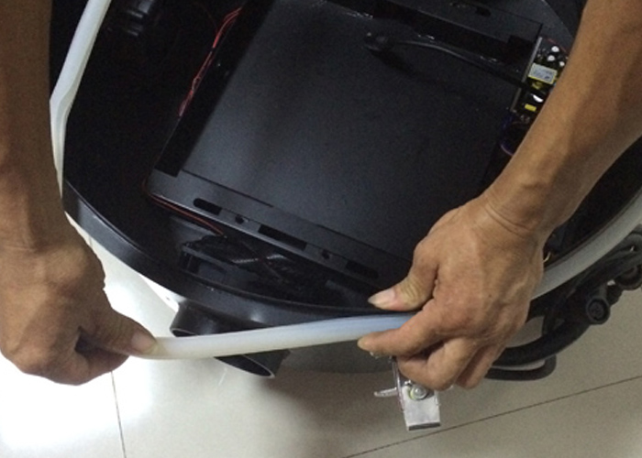
- 将连接板两边的固定螺丝取下 Take off the fixed screws on both sides of the connecting board.
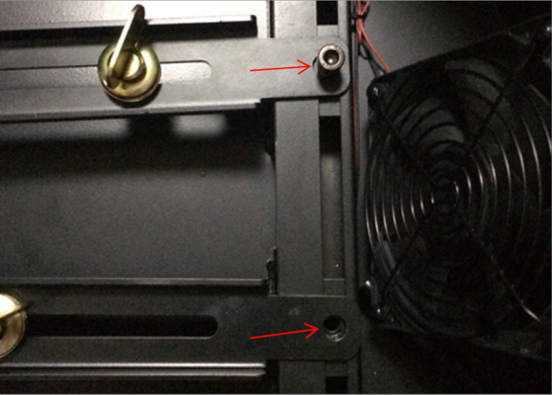
- 取出底座的连接板与灯具连接，根据灯具的大小位置调节，快速锁拧紧。
Connect the board and light, and adjust it according to the light, then screw them tightly.
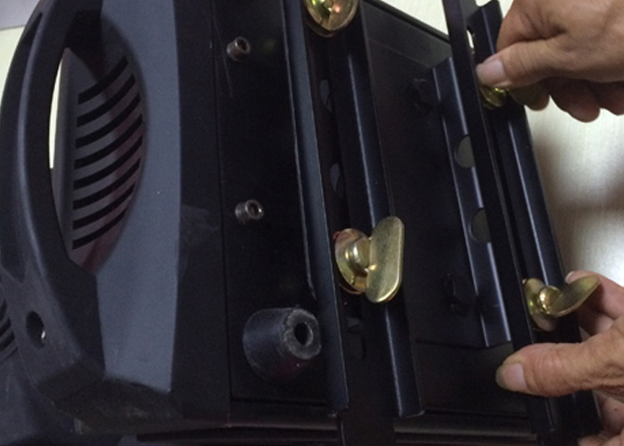
- 将灯具放置底座中，用原取下的螺丝固定连接
Put the connecting light and board on the base, and screaw-in the screaws have been taken off.
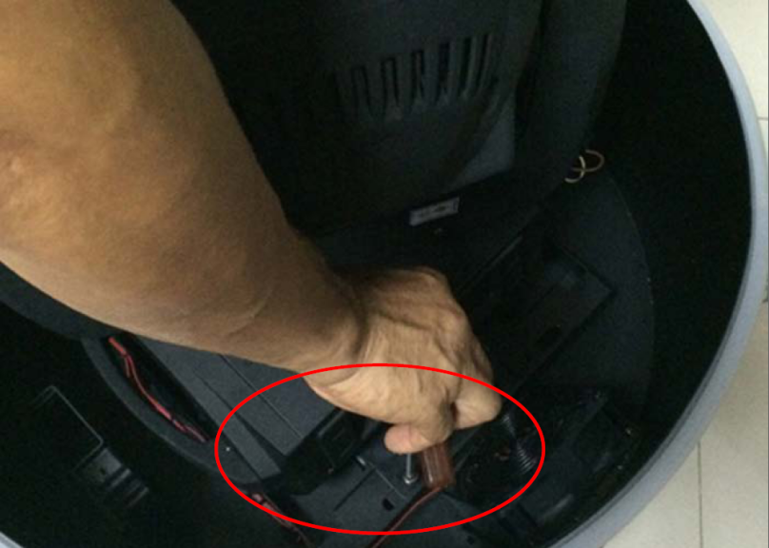
- 将透明罩与底座连接，用底座蝴蝶扣与透明罩固定
Put the cover on the base and fix it with the metal button on the base.
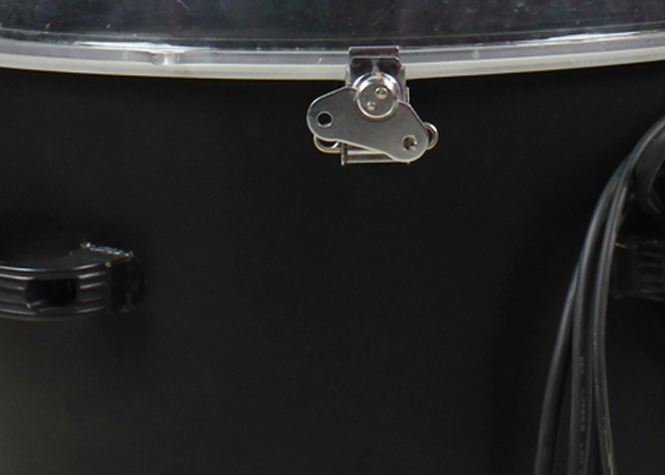
- 将配套通风弯口与底座连接Connect the tube on the base.
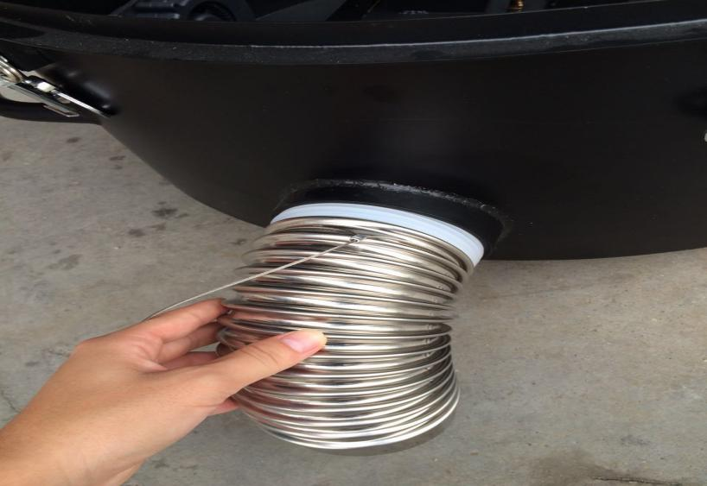
- 两边安全绳的连接Fasten the metal button and the tube.
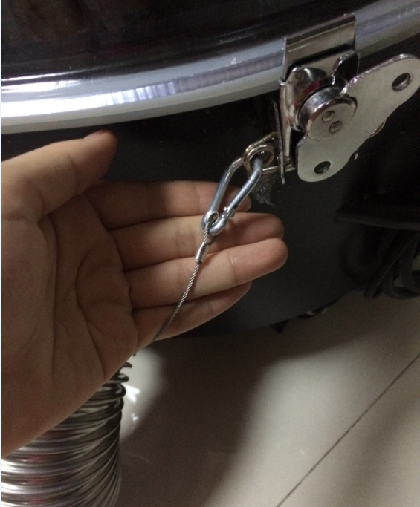
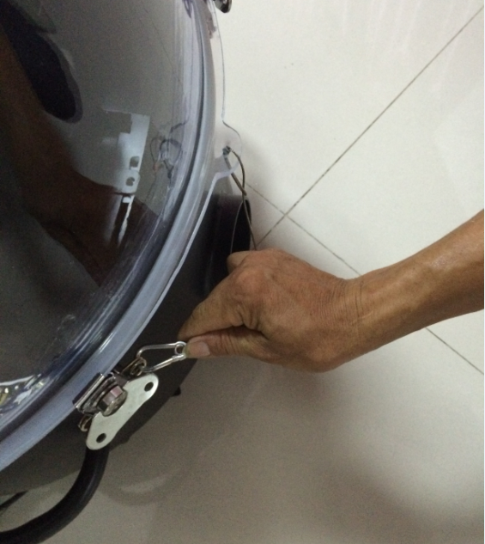
- 安装完毕
Installation OK
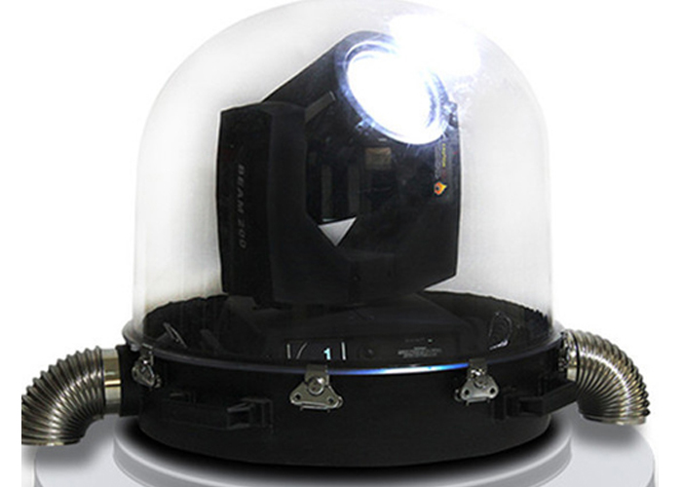

注意事项Remark：
1.透明罩上不能有任何遮挡物
There should be nothing cover the waterproof cover when in use.
- 严禁带电拆装。
Do not disassemble the cover with electricity.
3.严禁遮挡进排风口，保留空间。
Do not cover the exhaust outlet and keep some space.

