Use Manual 6*6 Led Matrix Light

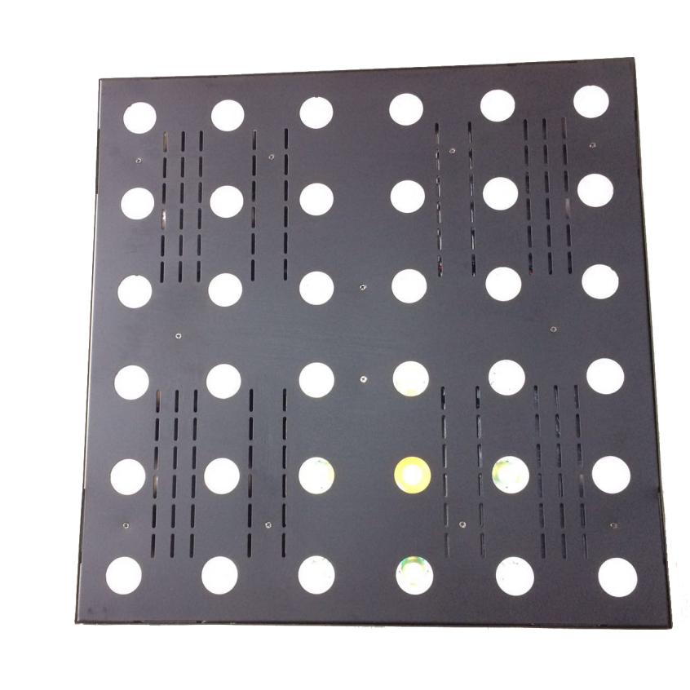

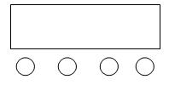
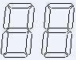
1.Digital display part:

A B C D
A: Function button
B. Up button
C.Down button
D.Enter button
- LED display function table (all the function selected by pressing the D (enter) to confirm)
No | Dispaly | Function Description
1 | d001~d512 | DMX512 channel address（001—512）  B、C key to addition and subtraction address code.
2 | 36ch/05ch | Channel selection (36 channels / 05 channels)  B, C key to addition and subtraction
3 | run1~run2 | Auto mode (built-in graphics self-walk, built-in effect from the walk)  B, C key to switch mode
4 | bE-1~bE-9 | Voice running change, (01-09)  B, C key to modify the voice sensitivity
5 | y000~y255 | LED test mode, (000-255)  B, C key to modify the brightness value

- DMX512 5 Channel description

NO | Function | description
Channel 1 | Dimmer | Dimmer, linear dimming, from dark to bright
Channel 2 | Strobe | Synchronous strobe, from slow to fast
Channel 3 | Built-in graphics | 0--4： Full bright；  5--9： Figure 1；  10--14： Figure 2；  。。。。。。。。  250--254： Figure 50；  255： Figure 51；  (Remark: graphics can be dimmed, strobe, priority is lower than the 4th channel)
Channel 4 | Built-in effect | 0--7： no；  8-15： Effect 1；  249-255： Effect 31；  (Remark: the effect mode can be dimmed, not strobe, the priority is higher than the third channel))
Channel 5 | Built-in running speed | Speed, from slow to fast)  Remark: 0-127 from fast to slow , ,128-255 reverse run from slow to fast

4．DMX512 36 Channel description
No | Function | description
Channel 1 | W1 Dimmer | W1 dimmer, linear dimming, dark to bright
Channel 2 | W2Dimmer | W2 dimmer, linear dimming, dark to bright
.... | ......Dimmer | ......dimmer, linear dimming, dark to bright
.... | ......Dimmer | ......dimmer, linear dimming, dark to bright
Channel 35 | W35 Dimmer | W35 dimmer, linear dimming, dark to bright
Channel 36 | W36 Dimmer | W36 dimmer, linear dimming, dark to bright
5.Features:
Operation is very easy with humanized design, no flicker and shaking when use dimmer. adapt to photography, take a photo ,television ect. or any lighting demand of the strict occasions.

